**HTML Tutorial: Semantic Tags in HTML| Web Development Tutorials #12**

**HTML Tutorial- Semantic Tags in HTML**

In this HTML tutorial, we are going to learn about **Semantics**in HTML. [Semantics](https://developer.mozilla.org/en-US/docs/Glossary/Semantics) are used to give proper meaning to the websites and help search engines to analyze it properly. Also, we can get help in return from different search engines in recognizing the original tags and their uses. For example, there are different tags used for the headers, navigation bars, body, and footers. So to analyze each and every tag properly, we have to use Semantics. The better the use of Semantics in a website, the more is the number of chances that it is being crawled by the search engines. It will also help in the better ranking of a website.

In very simple language, Semantic means to provide meaning to any word. If we talk in about a web page, then earlier most of the websites are made only using *divs* including different classes and IDs in them. But that was not the correct way of telling the search engines that if the elements are header, footer, or any other body.

There are many examples of Semantics. You can take the reference of the internet to view all. Here are some of the important semantic elements-

* **<header>**
* **<nav>**
* **<section>**
* **<article>**
* **<footer>**

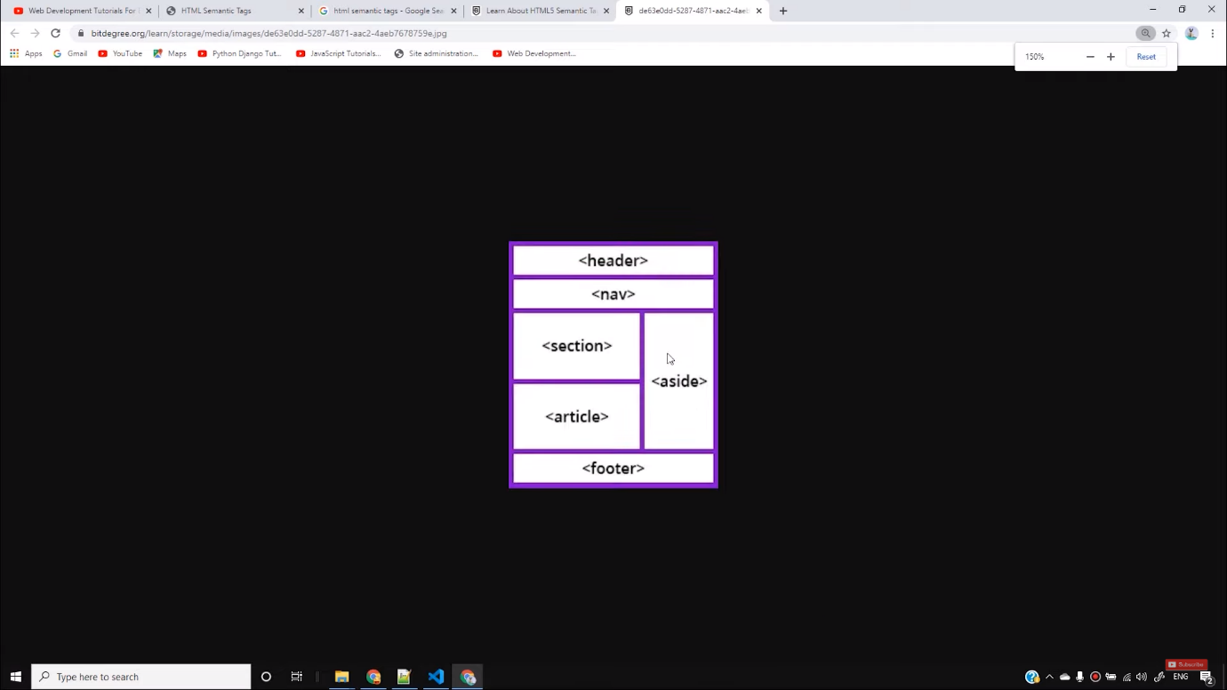

With these examples, the search engines can easily differentiate between headers, navigation bars, sections, bodies, and footers. Also, when we share the link of this website in social media, then the viewers will easily understand headings, sections, and body of a website.

But now the question arises, is it necessary to use all these things? The straight answer is **No**. It is not necessary to use the semantics but including it will help in the SEO part and increase the probability of ranking of your website. If you are working on a blog, then you must use this technique to improve its ranking. On the other hand, non-semantic elements do not justify their meaning. For example, div and span don't tell much what they do apart from the division between texts.

The semantics part in the HTML is not so difficult, therefore without wasting much time we will directly jump on the CSS section where we will learn to make some good looking and real websites. It is always better to learn HTML, CSS, and JavaScript each 75% rather than learning only 100% HTML. You should first try to build the basic foundation of web development and then keep learning step by step through practising. Because you will never be able to learn 100% of web development. Therefore, try to improve skills by practising more.

**Code as described/written in the video**

<!DOCTYPE html>

<html lang="en">

<head>

<meta charset="UTF-8">

<meta name="viewport" content="width=device-width, initial-scale=1.0">

<meta http-equiv="X-UA-Compatible" content="ie=edge">

<title>HTML Semantic Tags</title>

</head>

<body>

<h3>Semantic Elements</h3>

<details>

<summary>I have keys but no doors. I have space but no room. You can enter but can’t leave. What am I?

A keyboard.

A keyboard.

A keyboard.

A keyboard.

A keyboard.

A keyboard.

A keyboard.

A keyboard.

A keyboard.

A keyboard.

A keyboard.

A keyboard.

A keyboard.

A keyboard.

A keyboard.

A keyboard.

A keyboard.

A keyboard.

A keyboard.</summary>

lorem34

</details>

</body>

</html>

# HTML Semantic Elements

[❮ Previous](https://www.w3schools.com/html/html_computercode_elements.asp)[Next ❯](https://www.w3schools.com/html/html5_syntax.asp)

Semantic elements = elements with a meaning.

## **What are Semantic Elements?**

A semantic element clearly describes its meaning to both the browser and the developer.

Examples of **non-semantic** elements: <div> and <span> - Tells nothing about its content.

Examples of **semantic** elements: <form>, <table>, and <article> - Clearly defines its content.

## **Semantic Elements in HTML**

Many web sites contain HTML code like: <div id="nav"> <div class="header"> <div id="footer"> to indicate navigation, header, and footer.

In HTML there are some semantic elements that can be used to define different parts of a web page:

* <article>
* <aside>
* <details>
* <figcaption>
* <figure>
* <footer>
* <header>
* <main>
* <mark>
* <nav>
* <section>
* <summary>
* <time>

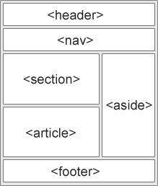

## **HTML <section> Element**

The <section> element defines a section in a document.

According to W3C's HTML documentation: "A section is a thematic grouping of content, typically with a heading."

Examples of where a <section> element can be used:

* Chapters
* Introduction
* News items
* Contact information

A web page could normally be split into sections for introduction, content, and contact information.

### **Example**

Two sections in a document:

<section>  
<h1>WWF</h1>  
<p>The World Wide Fund for Nature (WWF) is an international organization working on issues regarding the conservation, research and restoration of the environment, formerly named the World Wildlife Fund. WWF was founded in 1961.</p>  
</section>  
  
<section>  
<h1>WWF's Panda symbol</h1>  
<p>The Panda has become the symbol of WWF. The well-known panda logo of WWF originated from a panda named Chi Chi that was transferred from the Beijing Zoo to the London Zoo in the same year of the establishment of WWF.</p>  
</section>

[Try it Yourself »](https://www.w3schools.com/html/tryit.asp?filename=tryhtml5_section)

ADVERTISEMENT

## **HTML <article> Element**

The <article> element specifies independent, self-contained content.

An article should make sense on its own, and it should be possible to distribute it independently from the rest of the web site.

Examples of where the <article> element can be used:

* Forum posts
* Blog posts
* User comments
* Product cards
* Newspaper articles

### **Example**

Three articles with independent, self-contained content:

<article>  
<h2>Google Chrome</h2>  
<p>Google Chrome is a web browser developed by Google, released in 2008. Chrome is the world's most popular web browser today!</p>  
</article>  
  
<article>  
<h2>Mozilla Firefox</h2>  
<p>Mozilla Firefox is an open-source web browser developed by Mozilla. Firefox has been the second most popular web browser since January, 2018.</p>  
</article>  
  
<article>  
<h2>Microsoft Edge</h2>  
<p>Microsoft Edge is a web browser developed by Microsoft, released in 2015. Microsoft Edge replaced Internet Explorer.</p>  
</article>

[Try it Yourself »](https://www.w3schools.com/html/tryit.asp?filename=tryhtml5_article)

### **Example 2**

Use CSS to style the <article> element:

<html>  
<head>  
<style>  
.all-browsers {  
  margin: 0;  
  padding: 5px;  
  background-color: lightgray;  
}  
  
.all-browsers > h1, .browser {  
  margin: 10px;  
  padding: 5px;  
}  
  
.browser {  
  background: white;  
}  
  
.browser > h2, p {  
  margin: 4px;  
  font-size: 90%;  
}  
</style>  
</head>  
<body>  
  
<article class="all-browsers">  
  <h1>Most Popular Browsers</h1>  
  <article class="browser">  
    <h2>Google Chrome</h2>  
    <p>Google Chrome is a web browser developed by Google, released in 2008. Chrome is the world's most popular web browser today!</p>  
  </article>  
  <article class="browser">  
    <h2>Mozilla Firefox</h2>  
    <p>Mozilla Firefox is an open-source web browser developed by Mozilla. Firefox has been the second most popular web browser since January, 2018.</p>  
  </article>  
  <article class="browser">  
    <h2>Microsoft Edge</h2>  
    <p>Microsoft Edge is a web browser developed by Microsoft, released in 2015. Microsoft Edge replaced Internet Explorer.</p>  
  </article>  
</article>  
  
</body>  
</html>

[Try it Yourself »](https://www.w3schools.com/html/tryit.asp?filename=tryhtml5_article2)

## **Nesting <article> in <section> or Vice Versa?**

The <article> element specifies independent, self-contained content.

The <section> element defines section in a document.

Can we use the definitions to decide how to nest those elements? No, we cannot!

So, you will find HTML pages with <section> elements containing <article> elements, and <article> elements containing <section> elements.

## **HTML <header> Element**

The <header> element represents a container for introductory content or a set of navigational links.

A <header> element typically contains:

* one or more heading elements (<h1> - <h6>)
* logo or icon
* authorship information

**Note:** You can have several <header> elements in one HTML document. However, <header> cannot be placed within a <footer>, <address> or another <header> element.

### **Example**

A header for an <article>:

<article>  
  <header>  
    <h1>What Does WWF Do?</h1>  
    <p>WWF's mission:</p>  
  </header>  
  <p>WWF's mission is to stop the degradation of our planet's natural environment,  
  and build a future in which humans live in harmony with nature.</p>  
</article>

[Try it Yourself »](https://www.w3schools.com/html/tryit.asp?filename=tryhtml5_header)

## **HTML <footer> Element**

The <footer> element defines a footer for a document or section.

A <footer> element typically contains:

* authorship information
* copyright information
* contact information
* sitemap
* back to top links
* related documents

You can have several <footer> elements in one document.

### **Example**

A footer section in a document:

<footer>  
  <p>Author: Hege Refsnes</p>  
  <p><a href="mailto:hege@example.com">hege@example.com</a></p>  
</footer>

[Try it Yourself »](https://www.w3schools.com/html/tryit.asp?filename=tryhtml5_footer)

## **HTML <nav> Element**

The <nav> element defines a set of navigation links.

Notice that NOT all links of a document should be inside a <nav> element. The <nav> element is intended only for major block of navigation links.

Browsers, such as screen readers for disabled users, can use this element to determine whether to omit the initial rendering of this content.

### **Example**

A set of navigation links:

<nav>  
  <a href="/html/">HTML</a> |  
  <a href="/css/">CSS</a> |  
  <a href="/js/">JavaScript</a> |  
  <a href="/jquery/">jQuery</a>  
</nav>

[Try it Yourself »](https://www.w3schools.com/html/tryit.asp?filename=tryhtml5_nav)

## **HTML <aside> Element**

The <aside> element defines some content aside from the content it is placed in (like a sidebar).

The <aside> content should be indirectly related to the surrounding content.

### **Example**

Display some content aside from the content it is placed in:

<p>My family and I visited The Epcot center this summer. The weather was nice, and Epcot was amazing! I had a great summer together with my family!</p>  
  
<aside>  
<h4>Epcot Center</h4>  
<p>Epcot is a theme park at Walt Disney World Resort featuring exciting attractions, international pavilions, award-winning fireworks and seasonal special events.</p>  
</aside>

[Try it Yourself »](https://www.w3schools.com/html/tryit.asp?filename=tryhtml5_aside)

### **Example 2**

Use CSS to style the <aside> element:

<html>  
<head>  
<style>  
aside {  
  width: 30%;  
  padding-left: 15px;  
  margin-left: 15px;  
  float: right;  
  font-style: italic;  
  background-color: lightgray;  
}  
</style>  
</head>  
<body>  
  
<p>My family and I visited The Epcot center this summer. The weather was nice, and Epcot was amazing! I had a great summer together with my family!</p>  
  
<aside>  
<p>The Epcot center is a theme park at Walt Disney World Resort featuring exciting attractions, international pavilions, award-winning fireworks and seasonal special events.</p>  
</aside>  
  
<p>My family and I visited The Epcot center this summer. The weather was nice, and Epcot was amazing! I had a great summer together with my family!</p>  
<p>My family and I visited The Epcot center this summer. The weather was nice, and Epcot was amazing! I had a great summer together with my family!</p>  
  
</body>  
</html>

[Try it Yourself »](https://www.w3schools.com/html/tryit.asp?filename=tryhtml5_aside2)

## **HTML <figure> and <figcaption> Elements**

The <figure> tag specifies self-contained content, like illustrations, diagrams, photos, code listings, etc.

The <figcaption> tag defines a caption for a <figure> element. The <figcaption> element can be placed as the first or as the last child of a <figure> element.

The <img> element defines the actual image/illustration.

### **Example**

<figure>  
  <img src="pic_trulli.jpg" alt="Trulli">  
  <figcaption>Fig1. - Trulli, Puglia, Italy.</figcaption>  
</figure>

[Try it Yourself »](https://www.w3schools.com/html/tryit.asp?filename=tryhtml_figcaption)

## **Why Semantic Elements?**

According to the W3C: "A semantic Web allows data to be shared and reused across applications, enterprises, and communities."

## **Semantic Elements in HTML**

Below is a list of some of the semantic elements in HTML.

|  |  |
| --- | --- |
| **Tag** | **Description** |
| [<article>](https://www.w3schools.com/tags/tag_article.asp) | Defines independent, self-contained content |
| [<aside>](https://www.w3schools.com/tags/tag_aside.asp) | Defines content aside from the page content |
| [<details>](https://www.w3schools.com/tags/tag_details.asp) | Defines additional details that the user can view or hide |
| [<figcaption>](https://www.w3schools.com/tags/tag_figcaption.asp) | Defines a caption for a <figure> element |
| [<figure>](https://www.w3schools.com/tags/tag_figure.asp) | Specifies self-contained content, like illustrations, diagrams, photos, code listings, etc. |
| [<footer>](https://www.w3schools.com/tags/tag_footer.asp) | Defines a footer for a document or section |
| [<header>](https://www.w3schools.com/tags/tag_header.asp) | Specifies a header for a document or section |
| [<main>](https://www.w3schools.com/tags/tag_main.asp) | Specifies the main content of a document |
| [<mark>](https://www.w3schools.com/tags/tag_mark.asp) | Defines marked/highlighted text |
| [<nav>](https://www.w3schools.com/tags/tag_nav.asp) | Defines navigation links |
| [<section>](https://www.w3schools.com/tags/tag_section.asp) | Defines a section in a document |
| [<summary>](https://www.w3schools.com/tags/tag_summary.asp) | Defines a visible heading for a <details> element |
| [<time>](https://www.w3schools.com/tags/tag_time.asp) | Defines a date/time |